EX.NO: 03 REGRESSION AND OPTIMISATION
DATE: 04.02.26 [MULTI LINEAR AND POLYNOMIAL REGRESSION]

SCENARIO 1 : STUDENTS PERFORMANCE PREDICTION
Predicted vs Actual Exam Scores:
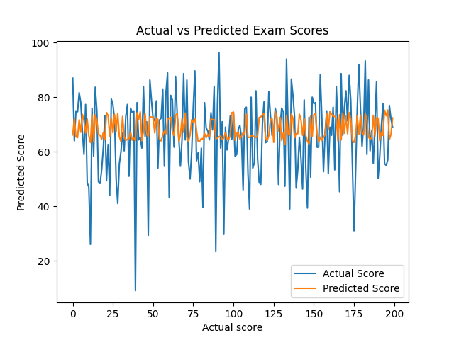

Regression Coefficient Comparison:
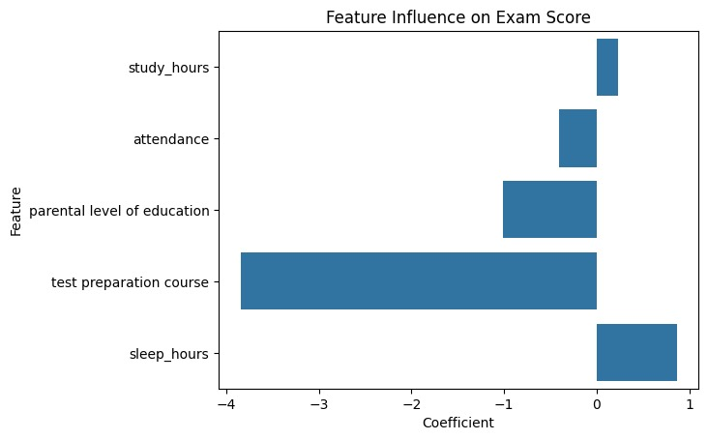
Residual Distribution:

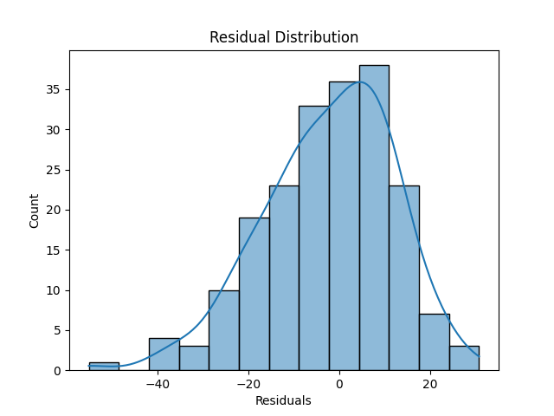

SCENARIO 2 : AUTO MGP
Training vs Testing comparison:
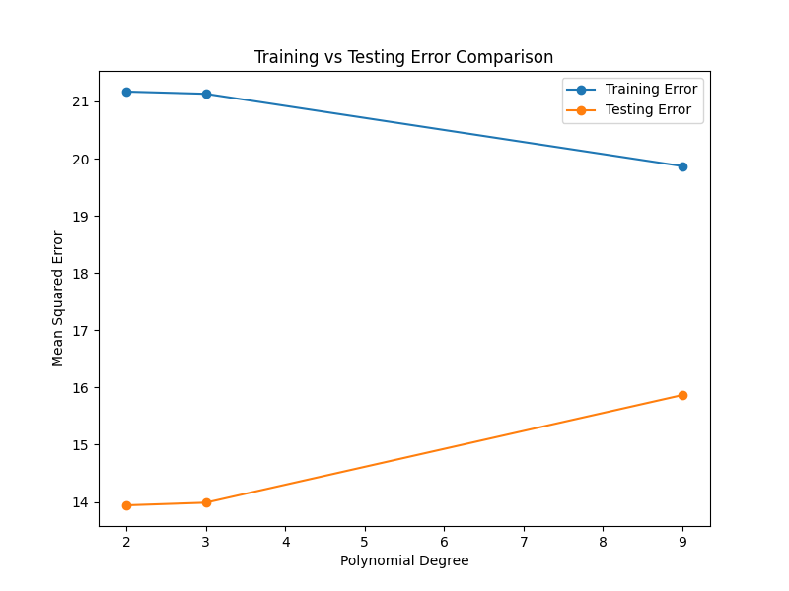
Polynomial Curve Fitting

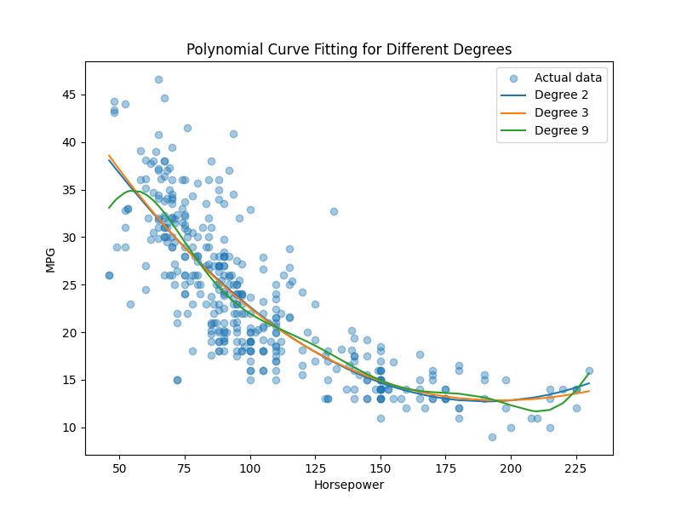
Underfitting vs Overfitting:
